

PAMISHETTY KEERMANI

CH.SC.U4CSE24113

OBJECT ORIENTED PROGRAMMING

(23CSE111)

LAB RECORD



**AMRITA VISHWA VIDYAPEETHAM**

**AMRITA SCHOOL OF COMPUTING, CHENNAI**

**BONAFIDE CERTIFICATE**

This is to certify that the Lab Record work for 23CSE111- Object Oriented Programming Subject submitted by **CH.SC.U4CSE24135 – PAMISHETTY KEERMANI** in “Computer Science and Engineering” is a Bonafide record of the work carried out under my guidance and supervision at Amrita School of Computing, Chennai.

This Lab examination on held on

Internal Examiner 1 Internal Examiner 2

|  |  |  |
| --- | --- | --- |
| **S no** | **title** | **Page no** |
| 1 | Online shopping |  |
| A | Use case diagram | **2** |
| B | Class diagram | **3** |
| C | Sequence diagram | **4** |
| D | Object diagram | **5** |
| e | State activity table | **6** |
| 2 | Student registration |  |
| A | Use case diagram | **7** |
| B | Class diagram | **8** |
| c | Sequence diagram | **9** |
| D | Object diagram | **10** |
| e | State activity table | **11** |
| 3 | Basic java programs |  |
| A | Calorie counter | **12** |
| B | factorial | **13** |
| c | Leap year check | **13** |
| D | Multiplication calculator | **14** |
| e | Number reverser | **15** |
| F | Palindrome checker | **16** |
| G | Prime checker | **17** |
| h | Shopping discount | **18** |
| i | Star pattern | **19** |

**UML DIAGRAMS**

ONLINE SHOPPING

1 A) USE CASE DIAGRAM:

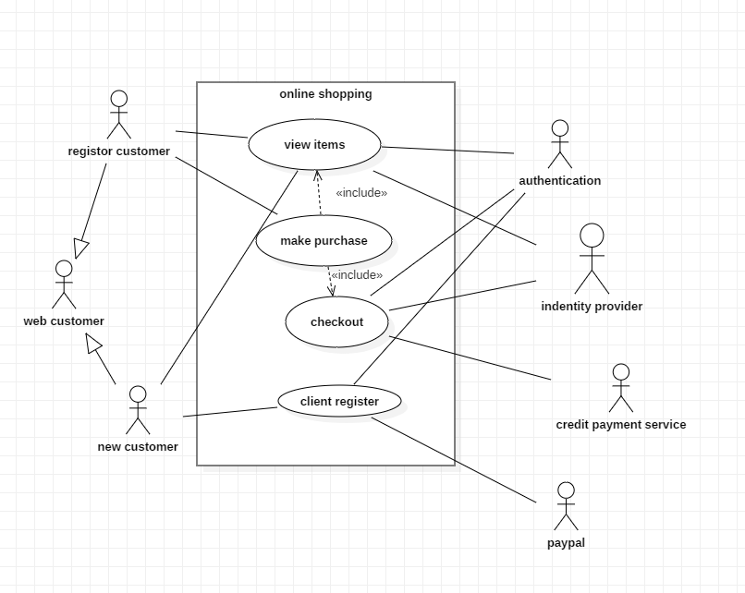

1 B) CLASS DIAGRAM:

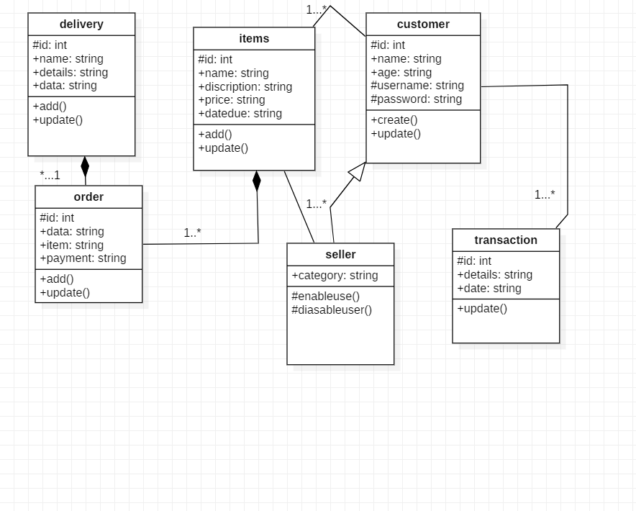

1 C) SEQUENCE DIAGRAM:

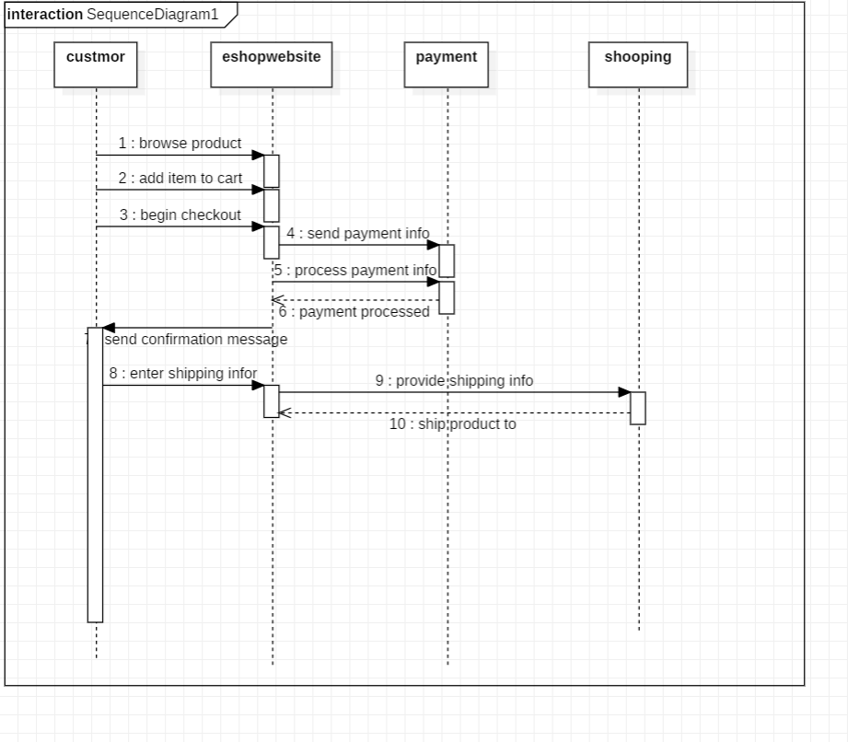

1 D) OBJECT DIAGRAM:

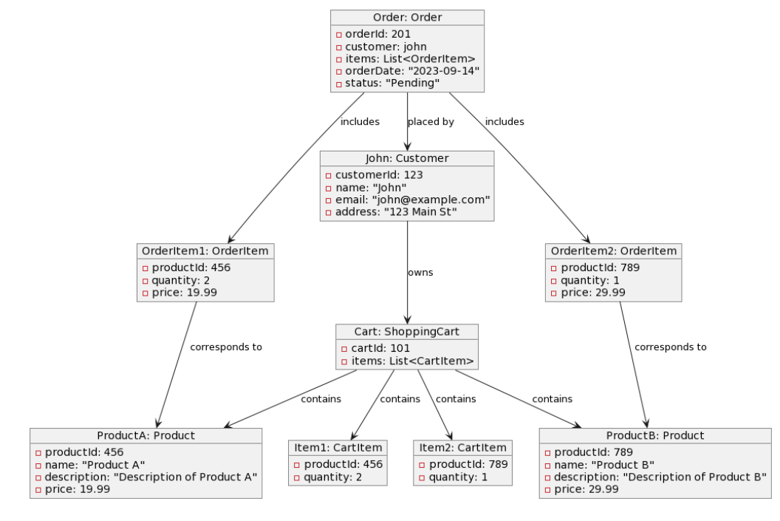

1 E) STATE ACTIVITY DIAGRAM:

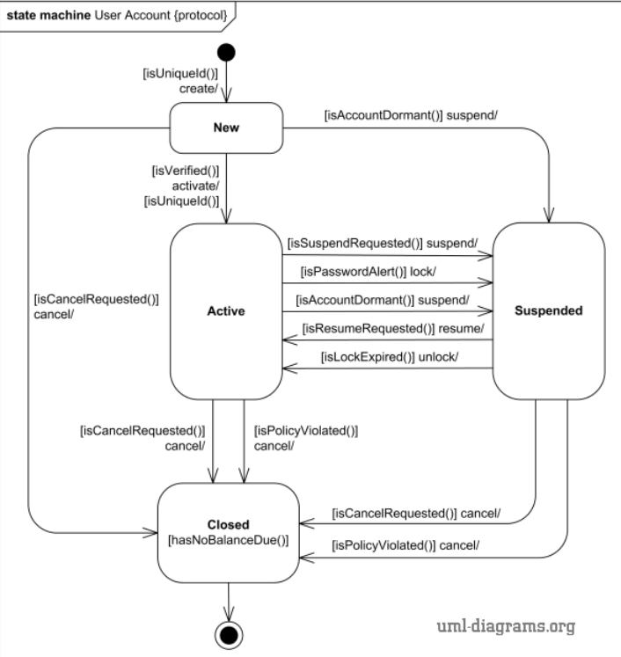

**STUDENT REGISTRATION**

1 A) USE CASE DIAGRAM:

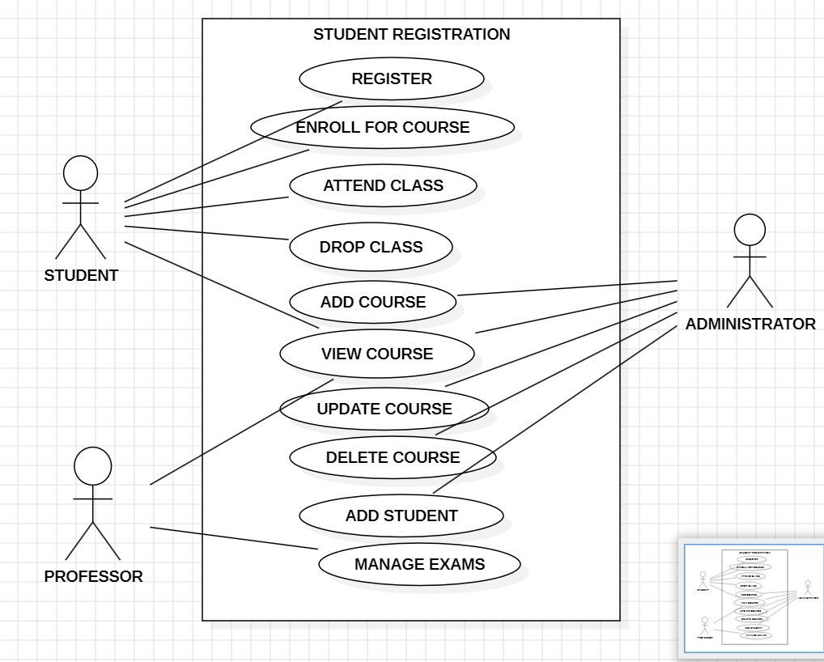

1 B) CLASS DIAGRAM:

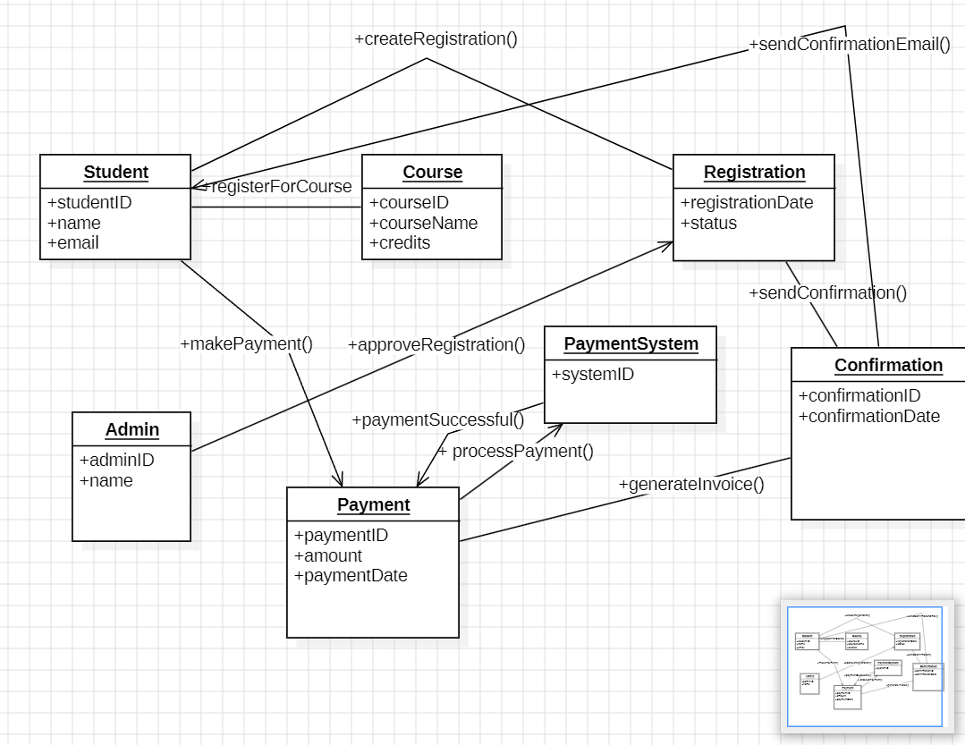

1 C) SEQUENCE DIAGRAM:

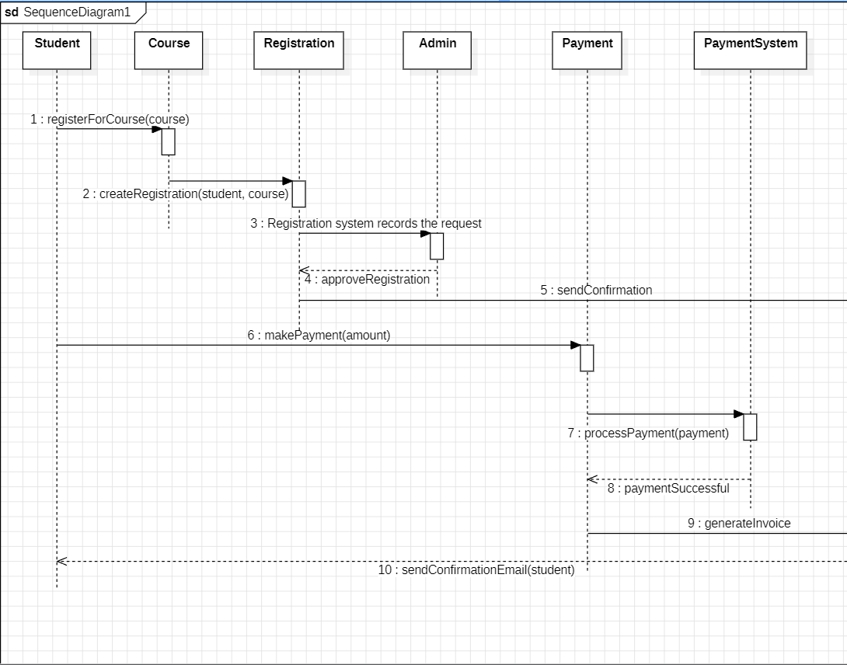

1 D) OBJECT DIAGRAM

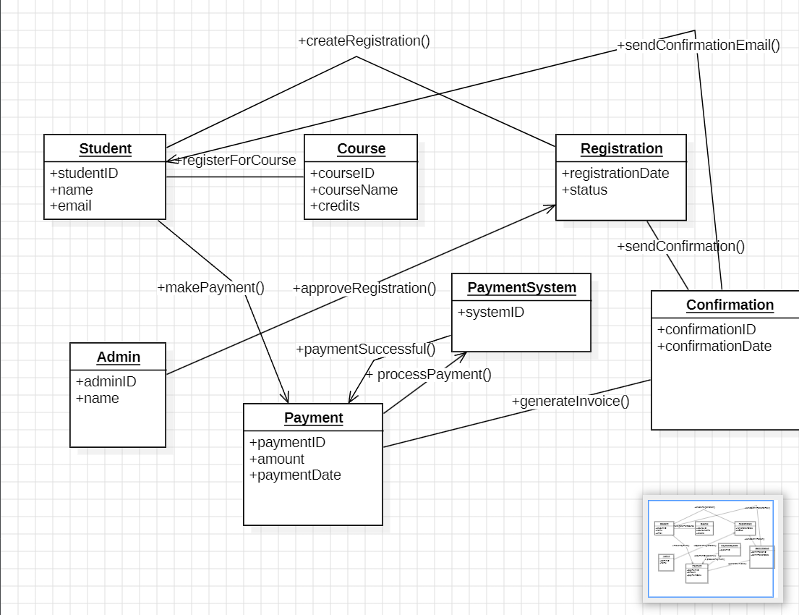

1 E) STATE DIAGRAM

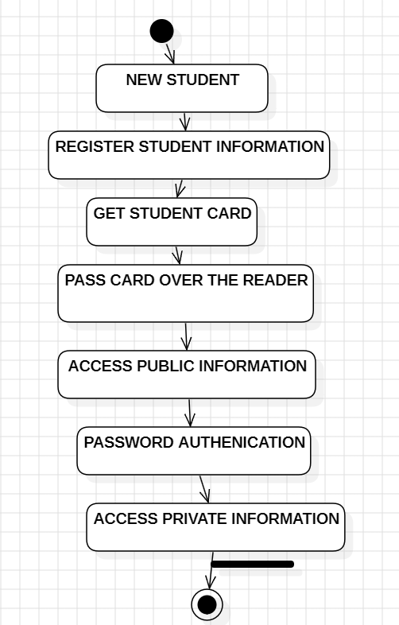

**3.Basic Java Programs**

3 a) Calorie Counter:

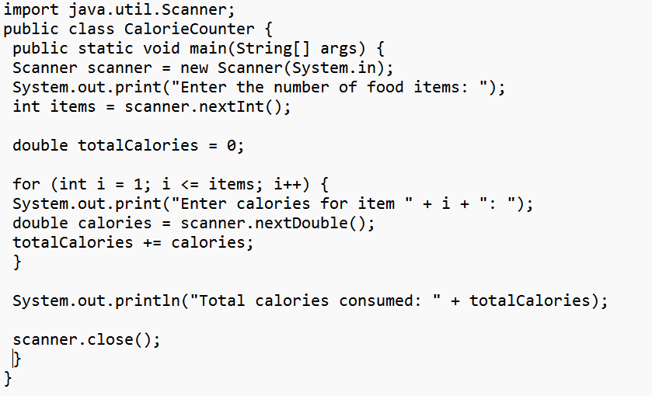

Output:

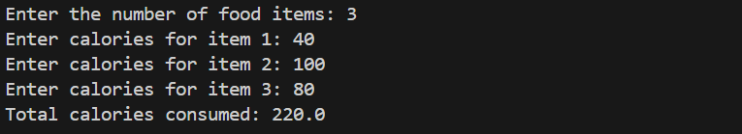

3 b) Factorial:

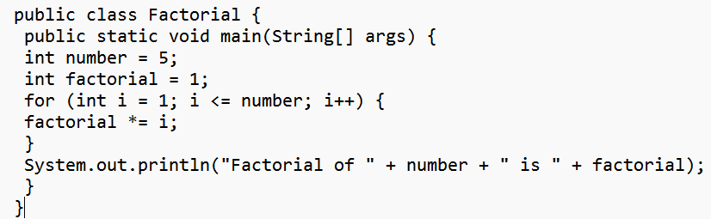

Output:



3 c) interest calculator:

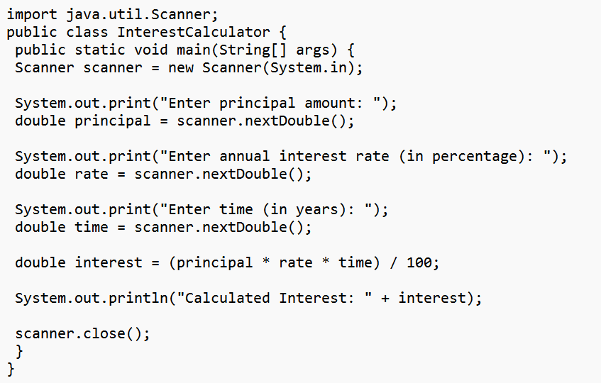

Output:

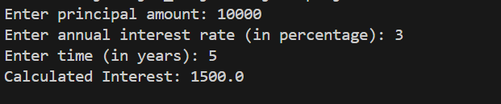

3 d) Leap Year Check:

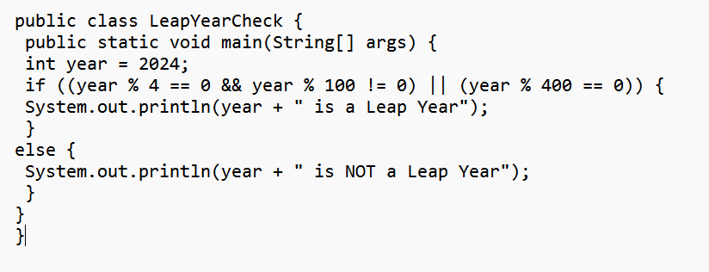

Output:



3 e) Multiplication Calculator:

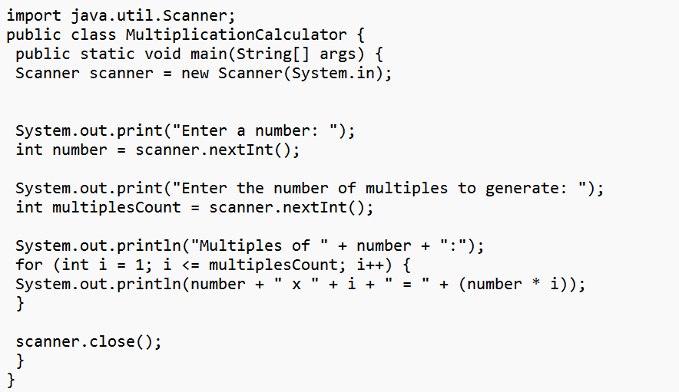

Output:

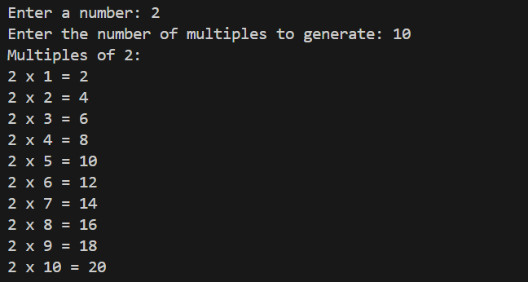

3 f) Number Reverse:

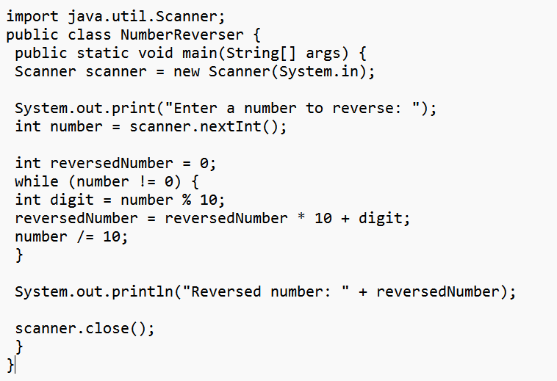

Output:

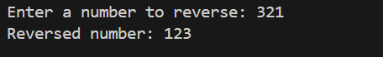

3 g) Palindrome Checker:

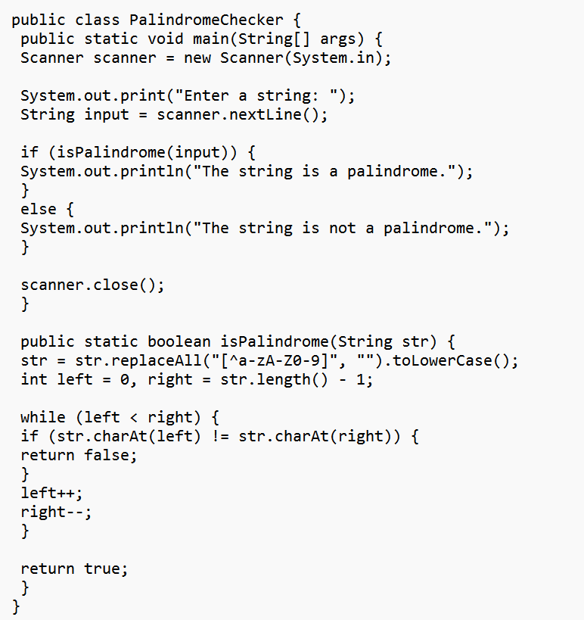

Output:

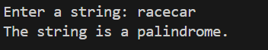

3 h) Prime Check:

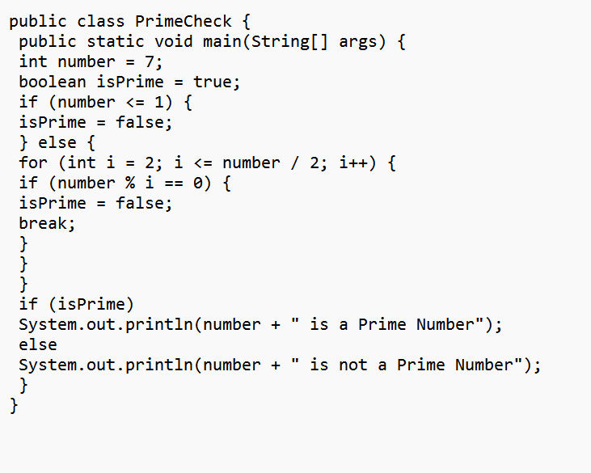

Output:



3 i) Shopping Discount:

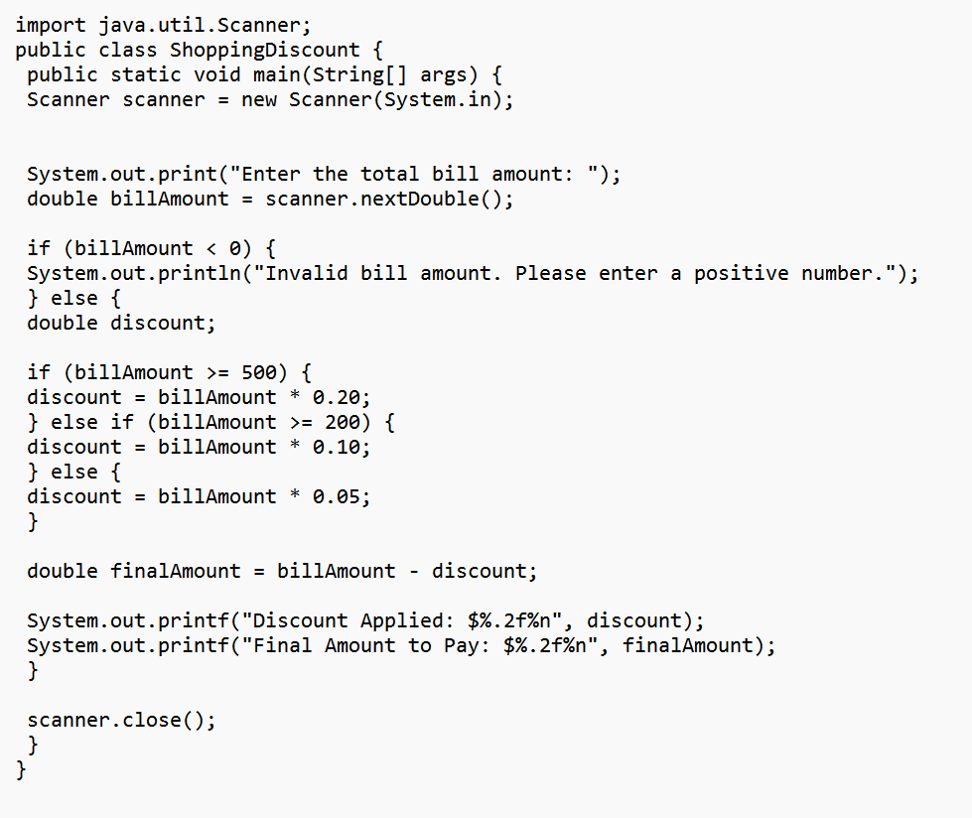

Output:

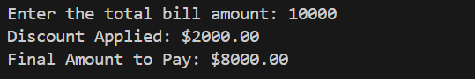

3 j) Star Pattern: 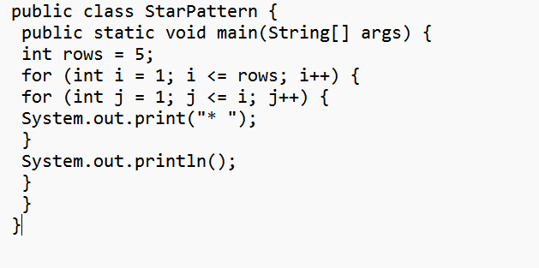

Output:

